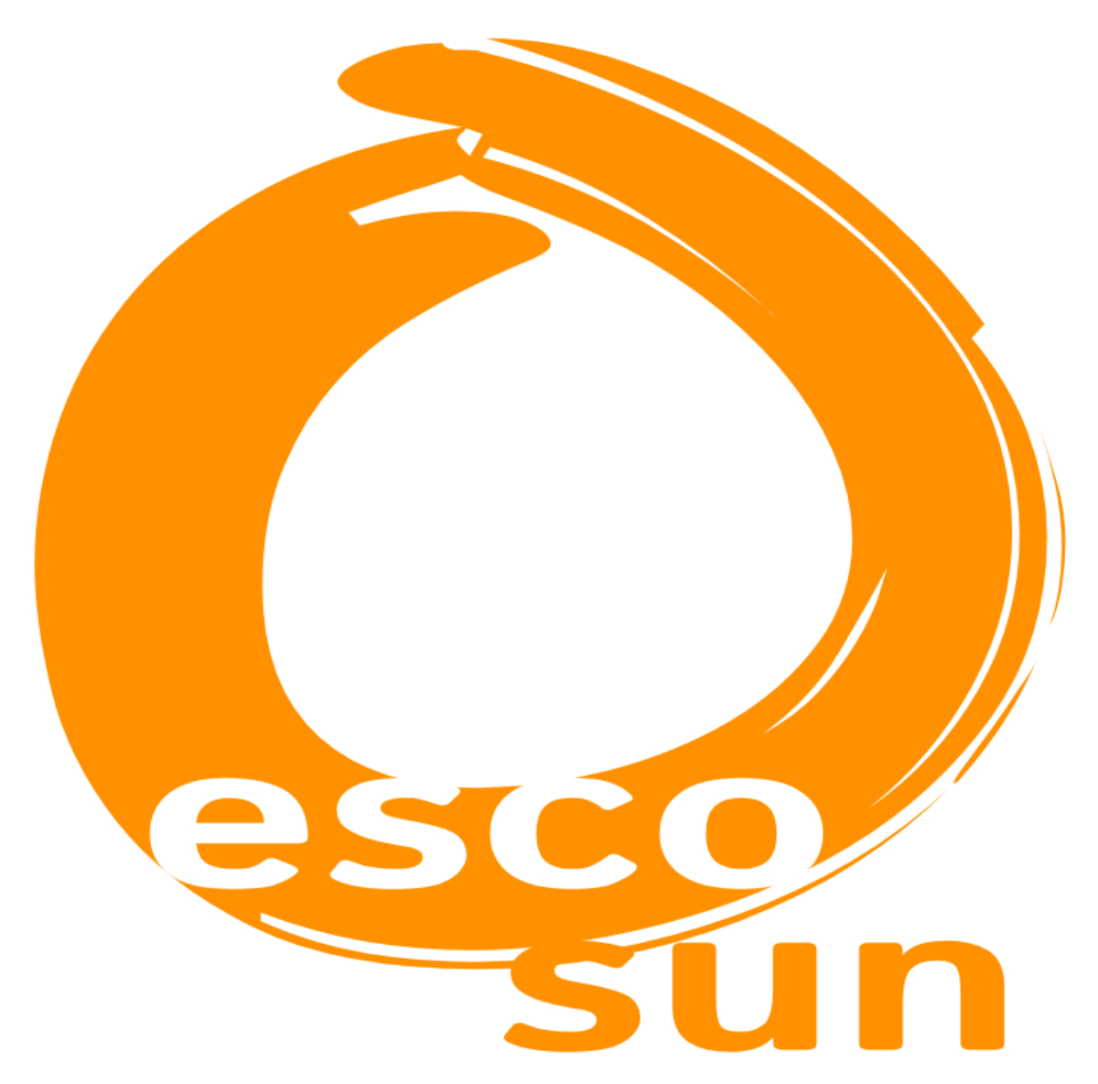
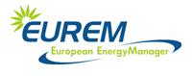


Macedonia Energy Day 2018

21 September 2018,

The Small Business Chamber of Commerce of the Republic of Macedonia
www.sbch.org.mk

Application form

The participation fee is 100 EUR.

Fields marked with an asterisk (*) are required to register.

Title:* First name:* Surname:*
Organization:*
Position:*
Email:*
Phone:*
Fax:*

Energy Efficiency experience:
[ ] I have no experience with Energy Efficiency
[ ] I have applied for Energy Efficiency project but have not participated yet
[ ] I have participated in the following project(s): …..................................

Would you like to display poster of your project or organization?
Number: [ ] Size: [ ] mm

Project idea:
Title:
Short description:

Consortium:

Where have you heard about the event?
[ ] Direct email [ ] From colleague/friend [ ] Website:
[ ] Other, please specify:

Please send back the application form
to info@sbch.org.mk

Phone: + 389 2 244 8077 / Fax: + 389 70 223 686

