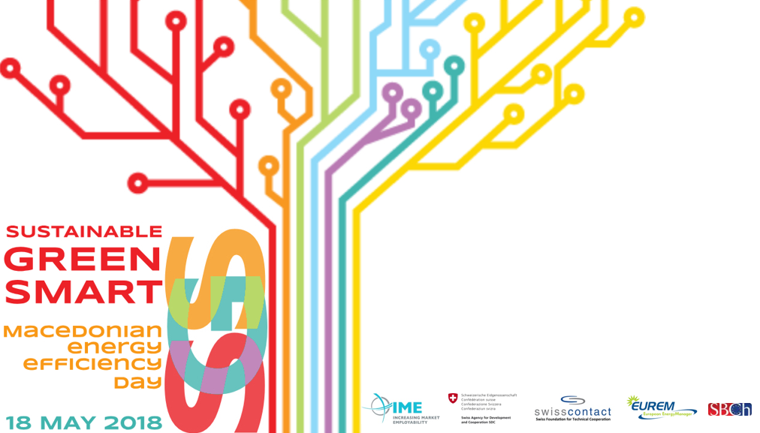

AGENDA

Friday, May 18, 2018
9.30 – 10.00 | Registration of participants
10.00 – 10.30 | Opening remarks
10.30 – 11.30 | Panel I: Enabling ESCO environment in the Republic of Macedonia
11.30 – 12.00 | Q&A Session on Panel I
12.00 – 12.30 | Coffee Break
12.30 – 13.45 | Panel II: Sustainable Smart Communities
13.45 – 14.15 | Q&A Session on Panel II
14.15 – 14.45 | Buffet Lunch
14.45 – 15.30 | Panel III: Challenge and transition towards low carbon economy
15.30 – 15.45 | Q&A Session on Panel III
15.45 – 16.00 | Conclusions

Moderators:  Panel I  Panel II  Panel III | Mitre Arsovski, EUREM MK Association of energy managers, President  Katerina Veljanovska Blazevska, MIT Univerity, Small Business Chamber of Commerce, President of the Assembly  Igor Mishevski, Green Economy Sector Manager, IME Programme  Visar Ademi, President and CEO of My Career, HELVETAS Swiss Interecoopeation project Co-facilitator  Darko Spirovski, Technical Consultant and Advisor at Institute for Environment and Health, SEE University
Speakers: Panel I | ESCo – Energy Service Company  Antonio Delov, EUREM MK Association of energy managers, member of the  Board  Business model for investments for replacement of old heating systems in households with new ones.  Darko Spirovski,  Technical Consultant and Advisor at Institute for Environment and Heallth, SEE  University  Energy Efficiency Law of Republic of Macedonia  Valentina Stardelova  Ministry of Economy, Energy Department  ESCo & PPP projects legislative challenges  Aleksandar Naumoski, Mayor, Municipality of Gjorce Petrov  Establishing an energy efficiency management service  Nikola Ushinov, EVN Macedonia, Energy planning and procurement manager  Switch Lignite to Natural Gas with Steam and Eletricitty CHP System Textile Industrial Facility Teteks RMG  Zarko Trpkovski, Teteks AD
Panel II | Sustainable Housing Prototype District  Stefan Ivanovski, Master of City Planning, concentration in community and economic development  Smart City Model  Aleksandar Zaovski, Sentrek, business developer  Green Cities Fit for Life – Ljubljana 2016 European Green Capital  Mira Lesjak, Embassy of the Republic of Slovenia, Minister Plenipotentiary  Municipalities Reconstruction Projects  Dimitar Grombanovski, Reconstruction of kindergarten "Buba mara", building - "Bee1", Municipality of Aerodrom, Skopje  Ivan Markovski, Reconstruction of primary school “Dimitar Berovski” Municipality of Gjorce Petrov  Dragan Natkov, Reconstruction of primary school “Malina Polivanova” Municipality of Kochani  Zlatko Pandovski, Increasing Energy Efficiency of SOTU ,,Gjorgi Naumov“ - Municipality of Bitola  Maja Todoroska - Study of modernization of lighting of the object and change of the building facade in the high school “Orde Chopela”
Panel III | Energy efficient buildings in 400kV and 110kV substations Sustainable Housing  Violeta Tasheva, MEPSO AD  Reconstruction of District Heating Substation for Pump Energy Efficiency  Igor Delidinkov, Project implemented in the company Distribution of Heat  Balkan Energy  Reconstruction of Central Heating System in Autobase in Avtokomanda and Gjorce Petrov  Mevljan Tairi, JSP Skopje

